Project Note – Living Planet Report Belgium

Project Note – Living Planet Report Belgium
Project Name | Living Planet Report Belgium
Sponsoring partner | WWF Belgium
Strategic partners | Natagora, Natuurpunt, Biodiversity Platform, Royal Belgian Institute of Natural Sciences (RBINS)
Project Lead | Olga Szczodry (WWF Belgium)
Members of the Board | Olga Szczodry (WWF Belgium), Jean-Yves Paquet (Natagora); Marc Herremans (Natuurpunt); Hilde Eggermont (Belgian Biodiversity Platform, Royal Belgian Institute of Natural Sciences),
Members of the Scientific Committee | Marc Herremans (Natuurpunt), Jean-Yves Paquet (Natagora), Marc Dufrène (Ulg), Lander Baeten (Ugent), Dirk Maes (INBO), Thomas Neyens (UHasselt), Arco Van Strien (CBS), René-Marie Lafontaine (RBINS), Pierre Rasmont (UMons), others tbd.  Chaired by Hendrik Segers (RBINS)
Members of the Stakeholder Committee | Frederik Leliaert (Botanical Garden Meise), Annick Schneiders (INBO), André Heughebaert (Biodiversity Platform), Lionel Delvaux (IEW), Marc Peeters (RBINS) other tbd.
Other partner(s) | Central Bureau of Statistiek, Royal Zoological Society of London, others tbd.
Approach | - The first phase of the project is the preparatory phase: this phase involves: General project development and management tasks, development of a network of relevant stakeholders in order to create boards and committees, data mapping, compilation of resources , understanding the LPR framework, understanding the criteria to be met to calculate an LPI , and its strong points and limitations, exploring different options for contracting institute on data analysis.  - The second phase is the data analysis phase: it involves data extraction, common database creation and LPI calculation and interpretation.  - The third phase of the project is the Content production phase: it involves decision on content, draft writing, securing pictures, design, etc.  - The last phase of the project is the Launching phase: it involves preparing a communication plan, organising the launch, and more (tbd).  In addition to the organisation of regular meetings of the board, several meetings of the scientific committee and occasional meetings of the stakeholder committee, two stakeholder sessions will be held during the project in order to inform the network (kick-off workshop and pre-launch event).
Timeline | 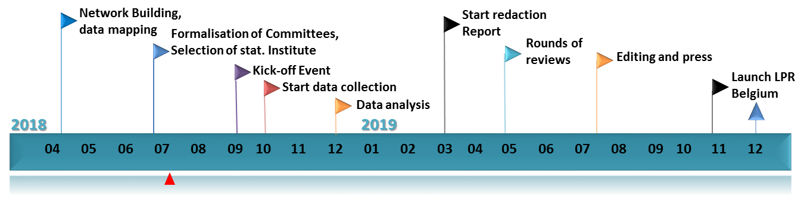
Description of prerogatives and duties for each functional group. | Project Lead:  Function:  Leading and coordinating the project to deliver a Living Planet Report Belgium as an output  Prerogatives:  - Guidance of the stakeholders (incl. board members) in line with the project process such as budget, LPR framework (incl. LPI, design of booklet, etc.)  - Final approval on items related to budget, project partners, timing, and final output  Duties:  - Delivering budget for the project (incl. hiring dedicated staff, payment for externalised services, communication campaign, launch):  - Coordination of project (contacting partners, writing contracts, organizing meetings or events, planning, etc.)  - Hosting workshops, meetings,  - Ensuring internal staff capacity (e.g. for running communication campaign)  - etc.  The Board: Composed of the sponsoring partner and strategic partners of the project  Function: Carrying out the LPR project throughout the whole process, in a collaborative, constructive way with a fair repartition of duties among members: it encompasses both decision-making and execution of well-defined tasks.  Prerogatives:  - Decisional role throughout the working process: on selection of partners, on the approach, on the methodology, on output interpretation, on content, on design, on wording, etc. (except on LPR framework and budget).  - Opportunity for capacity-building  - Logo on the front page of the report  - Reserved space in the foreword section  - Fair highlight of the member’s work in the report  - Acknowledgment as full/equal partner of the project in the public place  - Entitlement to use work and work products  - Collaboration on communication campaign (between respective comm. teams)  - Representation in communication campaign  - Media attention during Launch  Duties:  - Active participation in all editorial board meeting at a frequency corresponding to the needs of the project (approx. 1/month).  - Provision of constructive input for each decision to be taken throughout the project  - Effective realisation of the tasks assigned by the board during the editorial board meetings: e.g. data-mapping, information collection, contacting partners, following-up, content determination for the report, timely review of the content, etc.  - Sharing with the other members of the editorial board, all relevant information useful for the Living Planet report Belgium project (e.g. biodiversity data, knowledge, contacts, statistical scripts, expertise on methodology, etc.)  - Any other duty that will be deemed necessary by the board in order to carry out the project successfully.  Scientific Committee: Constituted of top Belgian scientists in biodiversity and/or ecological data management, coming from academia or public institutes.  Function:  Providing advice and reaching consensual answers to technical questions related to scientific approach on data aggregation, indicator calculation and analysis output interpretation. Advisory capacity, i.e. the board will take the formulated advice into account to the maximum possible extent.  Prerogatives:  - Opportunity to use their expertise for serving the biodiversity via their advisory role in the scientific committee  - Name on the verso side of the front page  - Fair acknowledgment of their input in the project (no financial compensation)  Duties:  - Active participation to the 4-5 scientific committee meetings organised throughout the project  - Constructive input to the debate on specific data-related question, in order to reach consensus  - Any other ‘small task’ that will be agreed upon during the scientific committee meetings (e.g. sending papers)  Stakeholder Committee: Consists of interested NGOs, partner institutes and administrations. Consultative role on (some parts of) the content of the report (focus text boxes, solutions, etc) and discussion on outreach  Function:  Providing suggestions, ideas on some parts of the content of the report (e.g. focus text boxes, chapter 3 on solutions, etc). Consultative capacity i.e. no obligation from the editorial board to take the input into account.  Prerogatives:  - Opportunity to take part to the project and influence the content of the report  - Name on the verso side of the front page  - Fair acknowledgment of their input in the project  Duties:  - Active participation to the 2-3 stakeholder meetings organised throughout the project  - Constructive input to the brainstorming sessions  - Any other task that was agreed during the stakeholder committee meeting (e.g. sending case study)

Decision-making will be reached most preferably by consensus. If consensus cannot be reached, a vote will be organised, and decisions will follow the majority. In case of equality of votes, the project lead will have to take the final decision;
LPR Framework comprises elements that need to be present to fit the qualification of a national “Living Planet Report”: it includes, a certain branding, format, design, the use of LPI as indicator including at national level, and a national approach)

